***Artificial Intelligence***

***CSL 411***

***Lab Journal 3***



**Student Name Saifullah Bhatti**

**Enrolment No.01-134182-047**

**Class and Section BSCS-6A**

**Department of Computer Science**

**BAHRIA UNIVERSITY, ISLAMABAD**

**Lab # 3: Rational Agents**

**Objectives:**

To implement Simple Reflex & Model Based Agent in Vacuum World.

**Tools Used:**

Python IDLE 3.4/Python IDLE 3.6

**Submission Date:**

**Evaluation: Signatures of Lab Engineer:**

**LAB EVALUATION**

**Task # 1:**

Consider the vacuum world shown in the figure below:

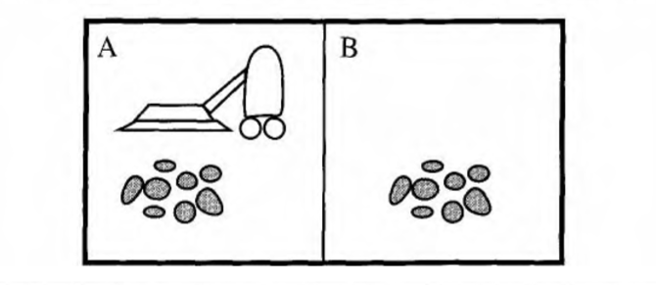

This particular world has just two locations: squares A and B. The vacuum agent perceives which square it is in and1 whether there is dirt in the square. It can choose to move left, move right, suck up the dirt, or do nothing. One very simple agent function is the following: if the current square is dirty, then suck, otherwise move to the other square. A simple program for the agent function of vacuum-world is shown below:

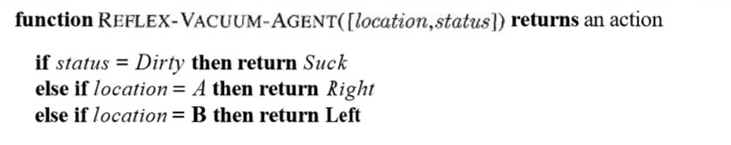

Your task is to implement the above vacuum world and its agent program for a simple reflex agent. Also, suggest a performance measure and evaluate your program based on that performance measure. Modify your program accordingly.

**Procedure/Program:**

**percept=['Dirty','Dirty']**

**actions=['Move Right','Move Left','Clean Dirt']**

**class Agent:**

**def _init_(self):**

**self.position=0**

**self.currAction=0**

**self.run_agent()**

**def run_agent(self):**

**for i in range(len(percept)):**

**self.getAction(percept[i])**

**def getAction(self,cPercept):**

**if (cPercept=="Dirty"):**

**print("Room is dirty. CLeaning the room")**

**self.currAction=actions[2]**

**self.updateRoom()**

**elif (cPercept=="Clean"):**

**if self.position==0:**

**self.currAction = actions[0]**

**self.updatePosition()**

**elif self.position==1:**

**self.currAction = actions[1]**

**self.updatePosition()**

**def updatePosition(self):**

**if self.currAction=="Move Right":**

**self.position=1**

**elif self.currAction=="Move Left":**

**self.position=0**

**def updateRoom(self):**

**if (self.currAction==actions[2]):**

**percept[self.position]="CLean"**

**x=str(self.position)**

**print("Room "+x+" is clean now")**

**V_agent=Agent()**